**Team 13: Java Swing app, Android and iOS app for IHO department**

Sponsor: Dr. Timothy Lindquist

Jaiswal, Arpit; Bhatt, Mihir; Nayak, Gowtham; Singhal, Sweta; Senathamil, Sindhu

**Update on Java Swing App:**

We have successfully implemented thumbnails for gallery, implemented separate image gallery for each lecturer and added featured news section to the Java Swing app. UI validations were also done during this sprint.

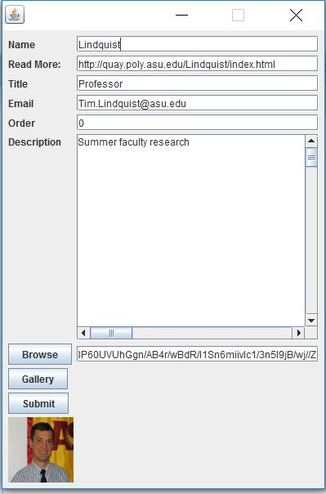

Figure Edit Lectures frame with image preview and lecturer gallery option

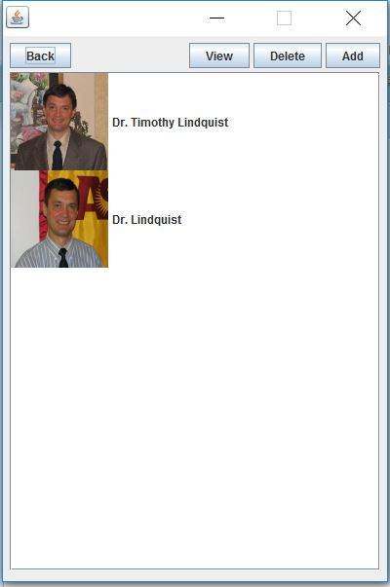

Figure Lecturer Gallery with options to update, add and delete any image

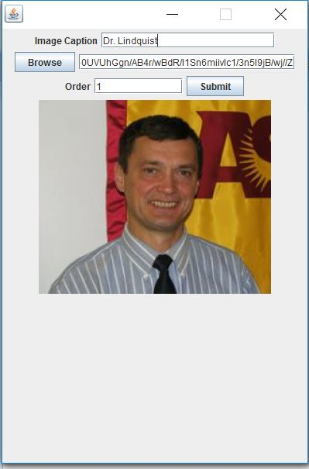

Figure : View page of each Lecturer Gallery; Provides option to edit each field

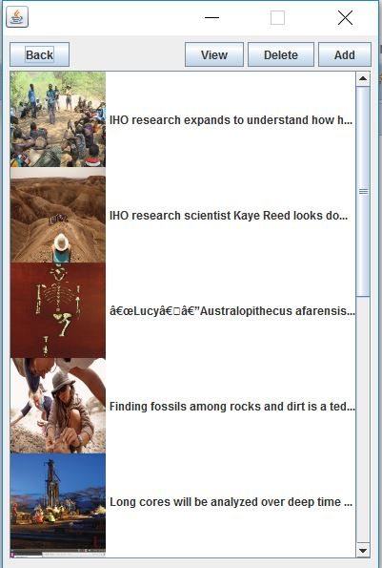

Figure Thumbnails for the gallery with option to view, add or delete the selected picture

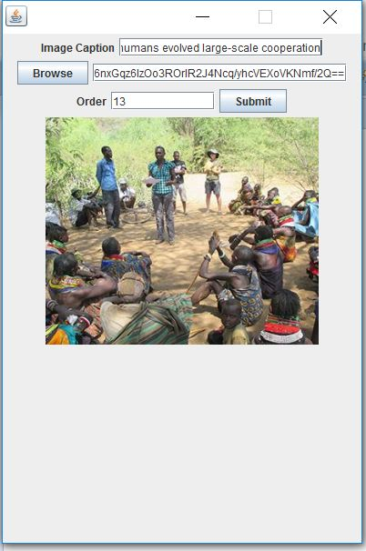

Figure View page of each image in the Gallery with options to edit each field

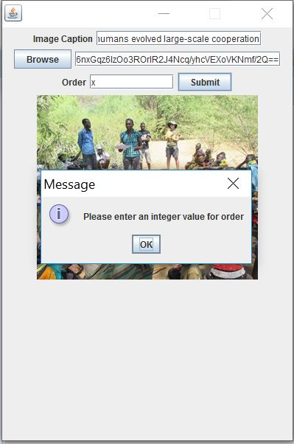

Figure Providing validation to enter only integer values for order field

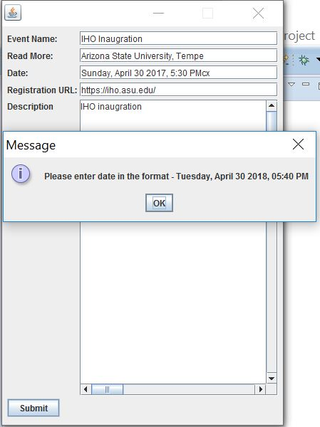

Figure Providing validation for the date and time to input the appropriate format

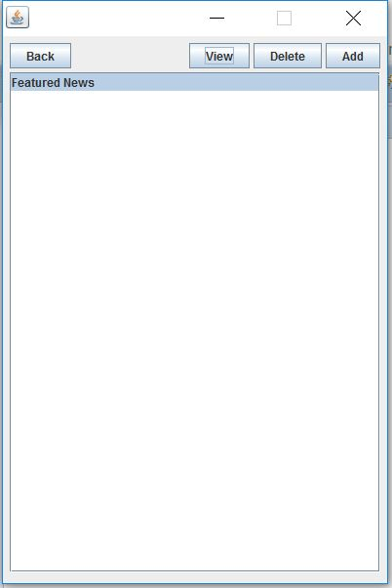

Figure 8 Featured News list which holds only one news object

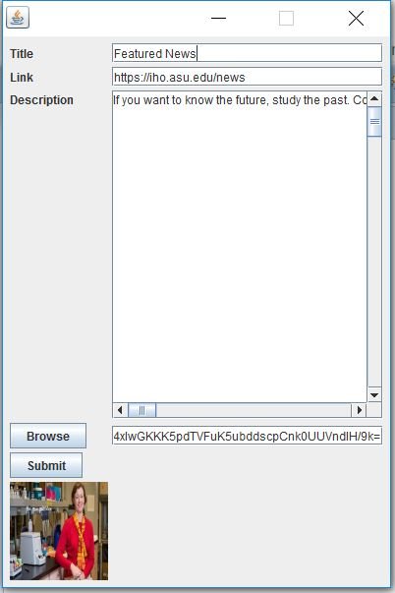

Figure Edit Featured News frame with image preview and provision for editing the contents

**Update on iOS app:**

We are creating the app from scratch in SWIFT 3. In sprint 3 we have completed the iOS app. We have implemented Lucy completed. We have also successfully implemented Gallery and Lecturer Gallery in this phase.

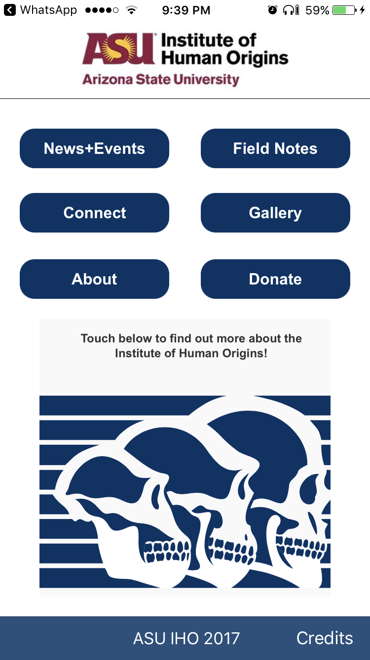

*Figure 10: Home Page of IHO app in iOS*

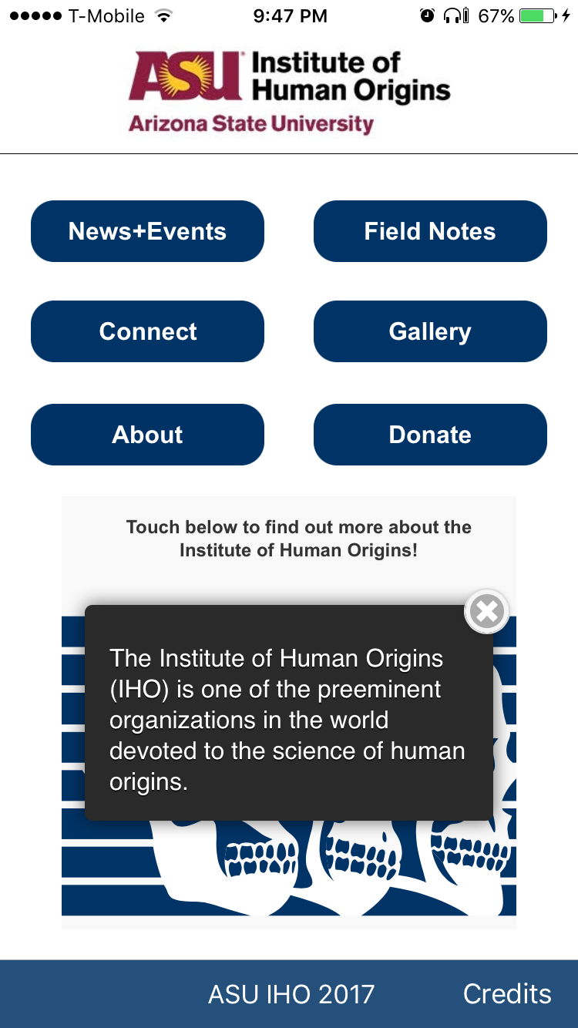

*Figure 11: Interactive Image on Home page which gives pop up when touched various parts..*

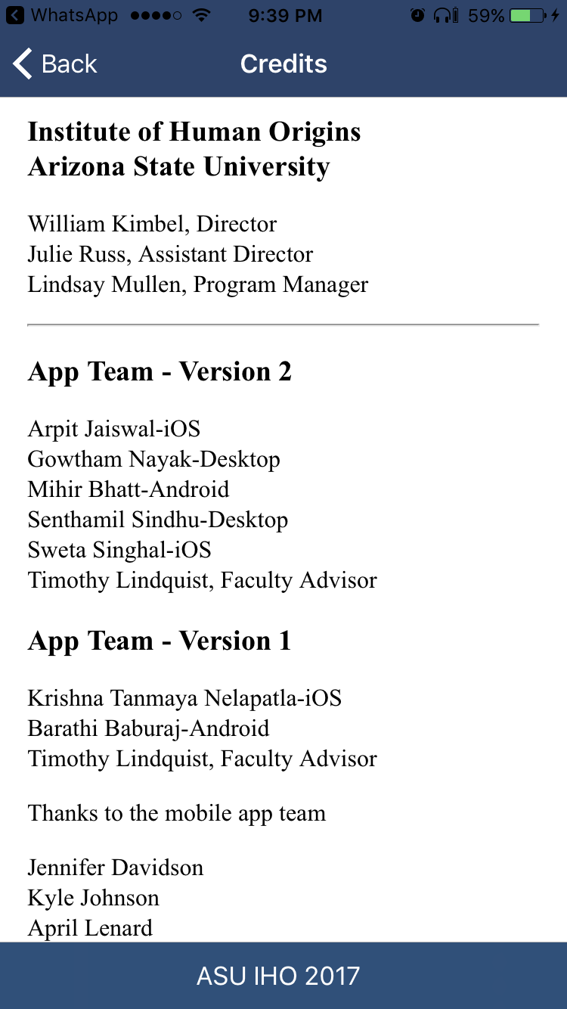

*Figure 12: Credits Pagefor IHO app*



*Figure 13: Gallery Home Page, redesigned with image for gallery home page..*

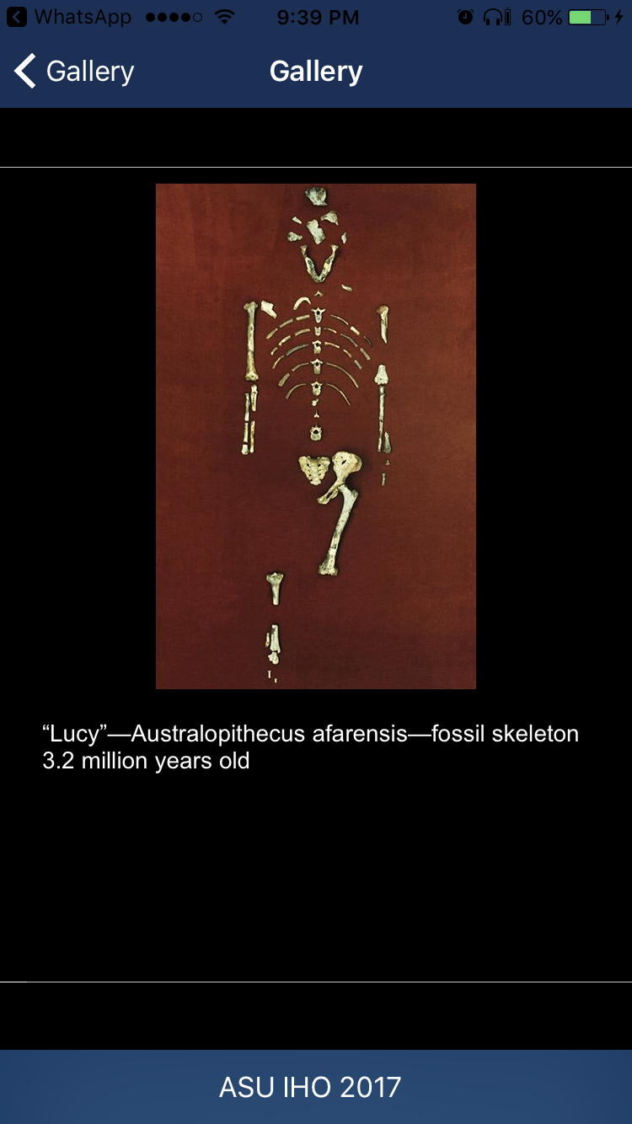

*Figure 14: Gallery with multiple images.*

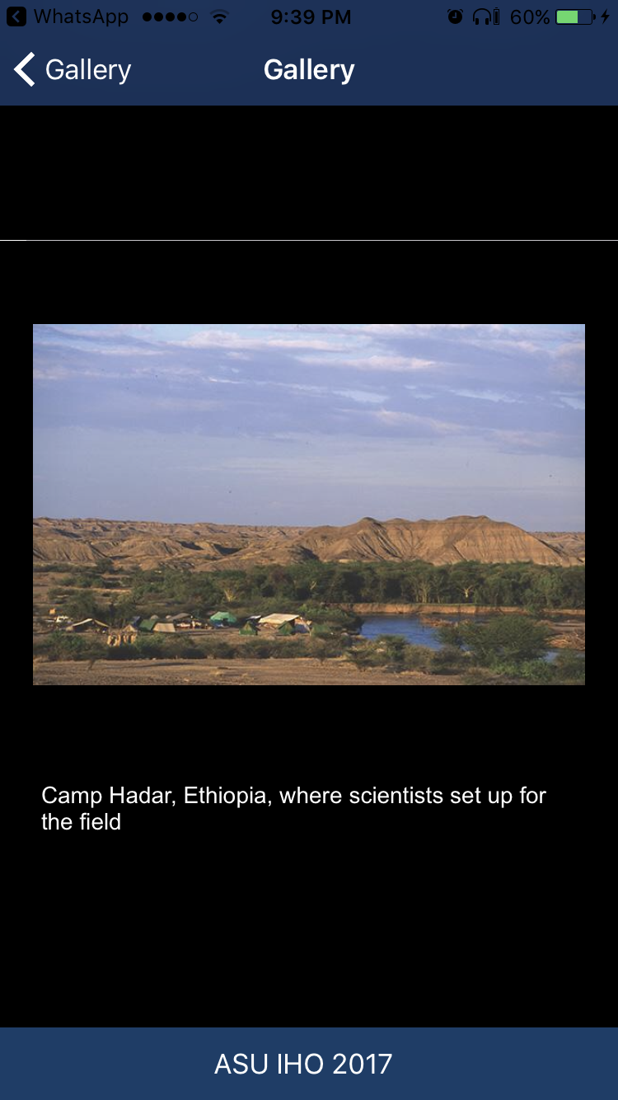

*Figure 15: Image Gallery*

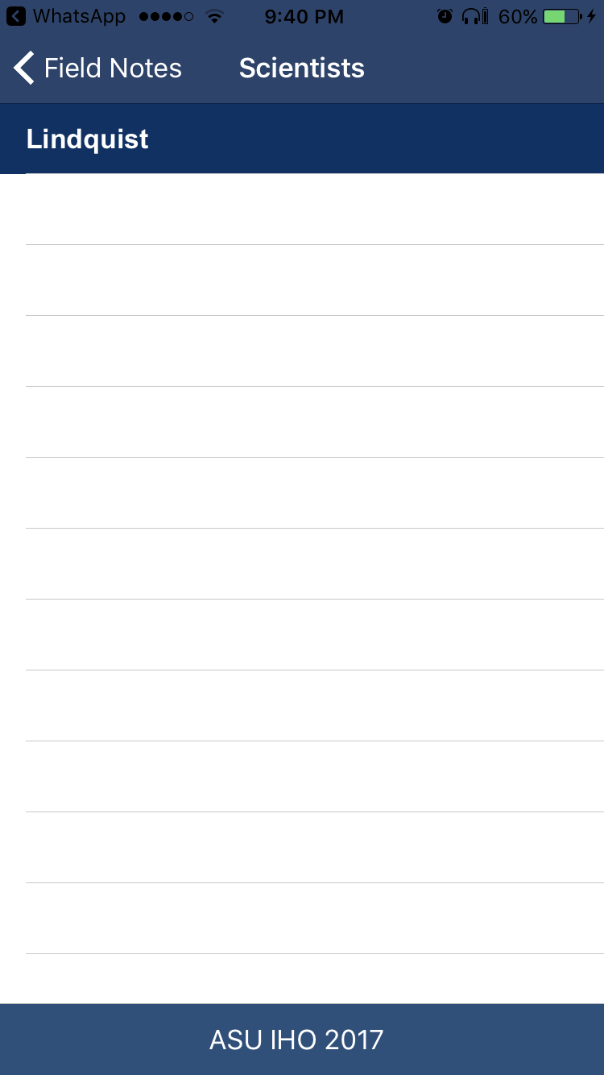

*Figure 16: List of Lecturer with dummy data*

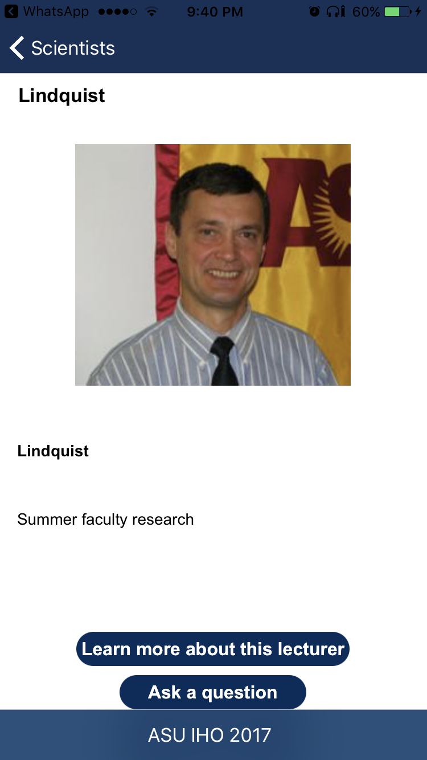

*Figure 17: Lecturer Detail*

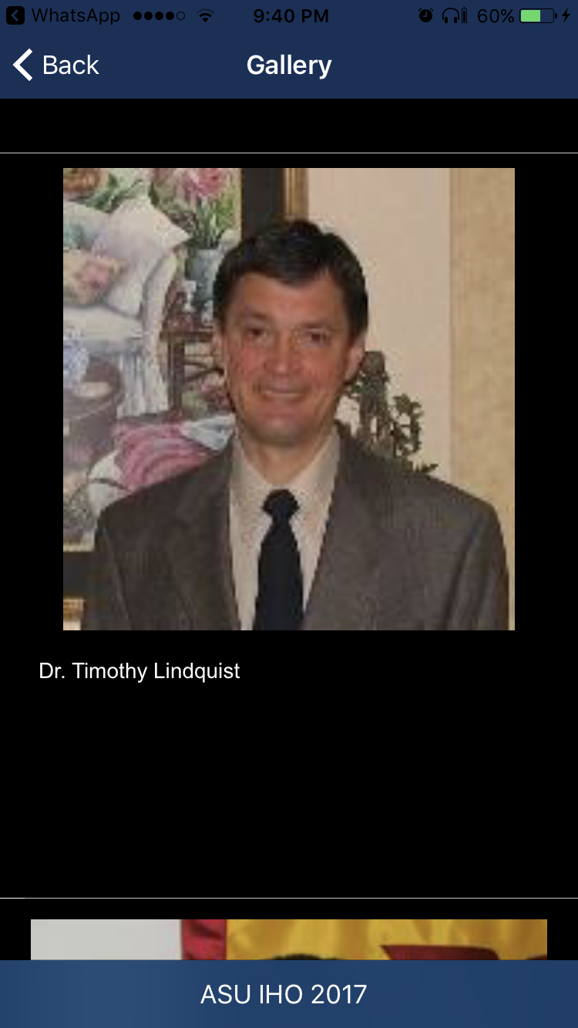

*Figure 18: Lecturer Gallery*

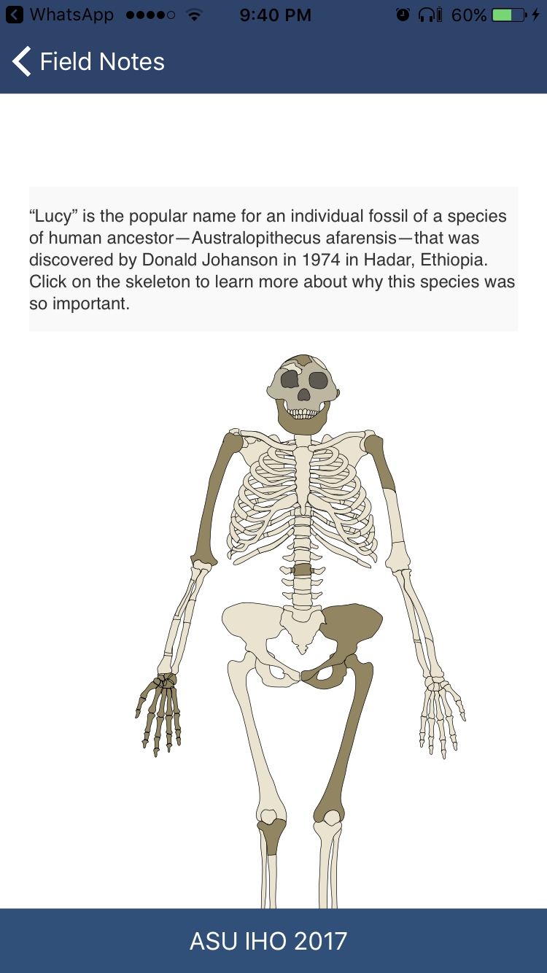

*Figure 19: Lucy Iteractive image*

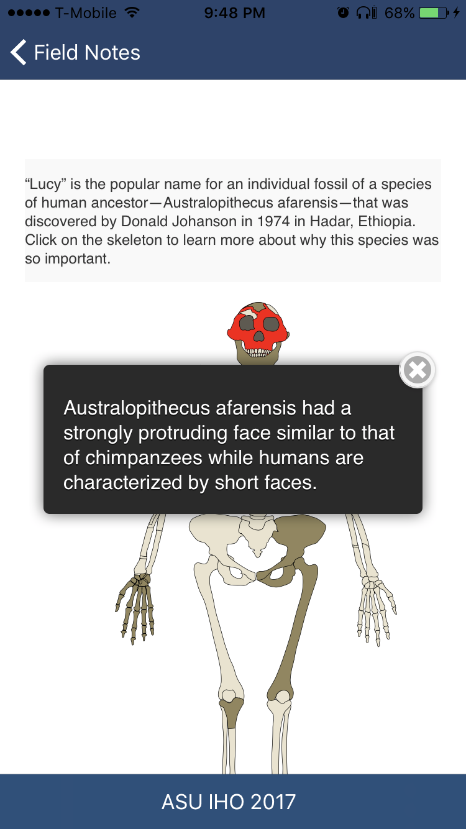

*Figure 20: Touch a part to see information about it.*

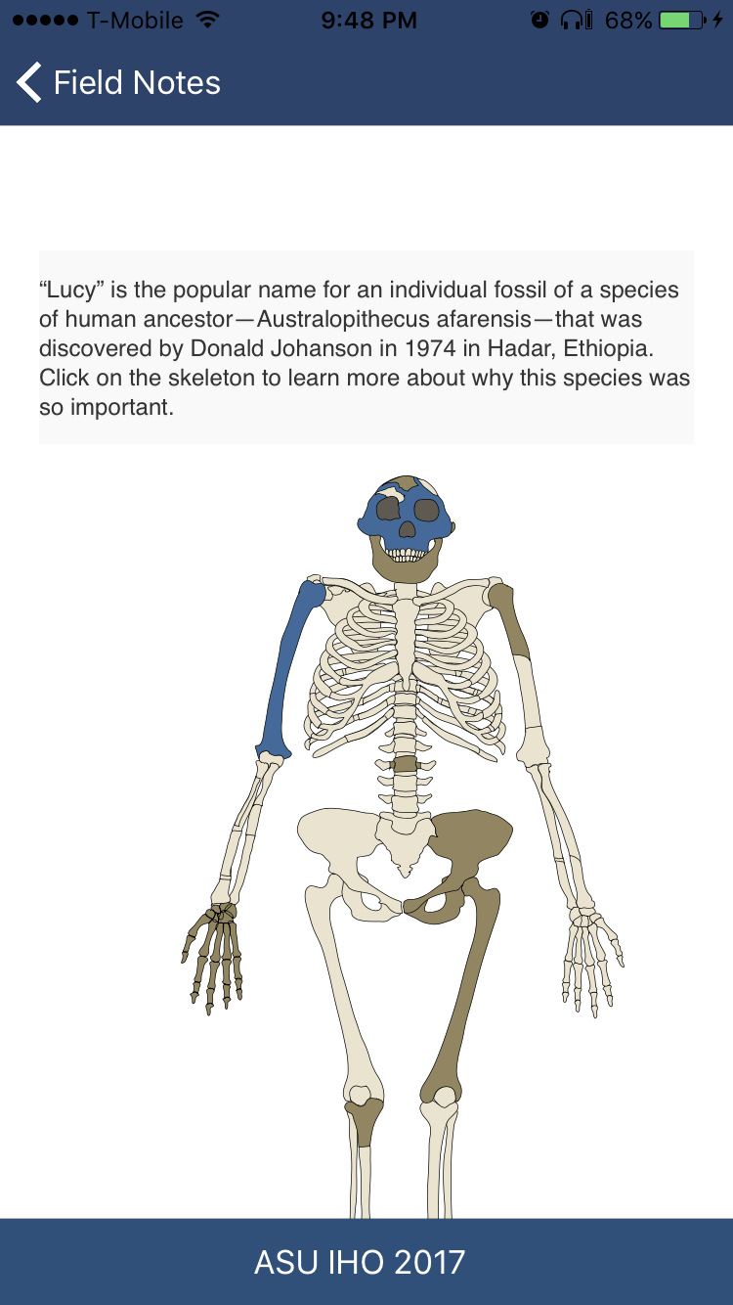

*Figure 21: After a part has been touched, the color changes to blue.*

**Update on Android app**

We have completed all the requirements given to us for the Android application. The application is ready to be published on the Google Play Store.

Specifically, in this sprint we worked on updating the dynamic content for Gallery Images, Lecturer Gallery, New Sciences and Featured News from the JSON server, wherein the content is pushed from the Swing App shown earlier. We have also implemented Local Cache and File Storage to deal with faster displaying content and incase when Internet is not available.

Along with that, we also worked in changing the design layout in most of the pages to make it look more beautiful and crisp, which includes larger size logos, changing image sizes for Gallery Images and Lecturer Gallery to fit the screen width.

Some of the screens from the today’s demo (Demo 3) are shown below, which would highlight the features indicated above.

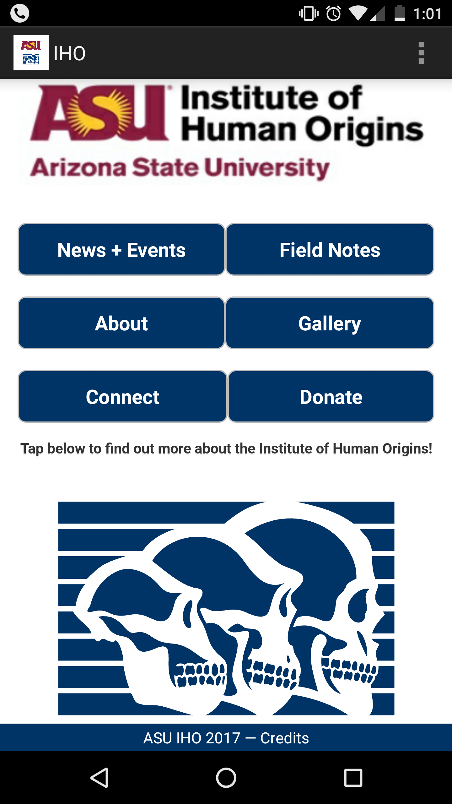

Figure 22: Android Application Home Page; showing crisp logo, 6 buttons, centered interactive Skull image and Credits Footer bar

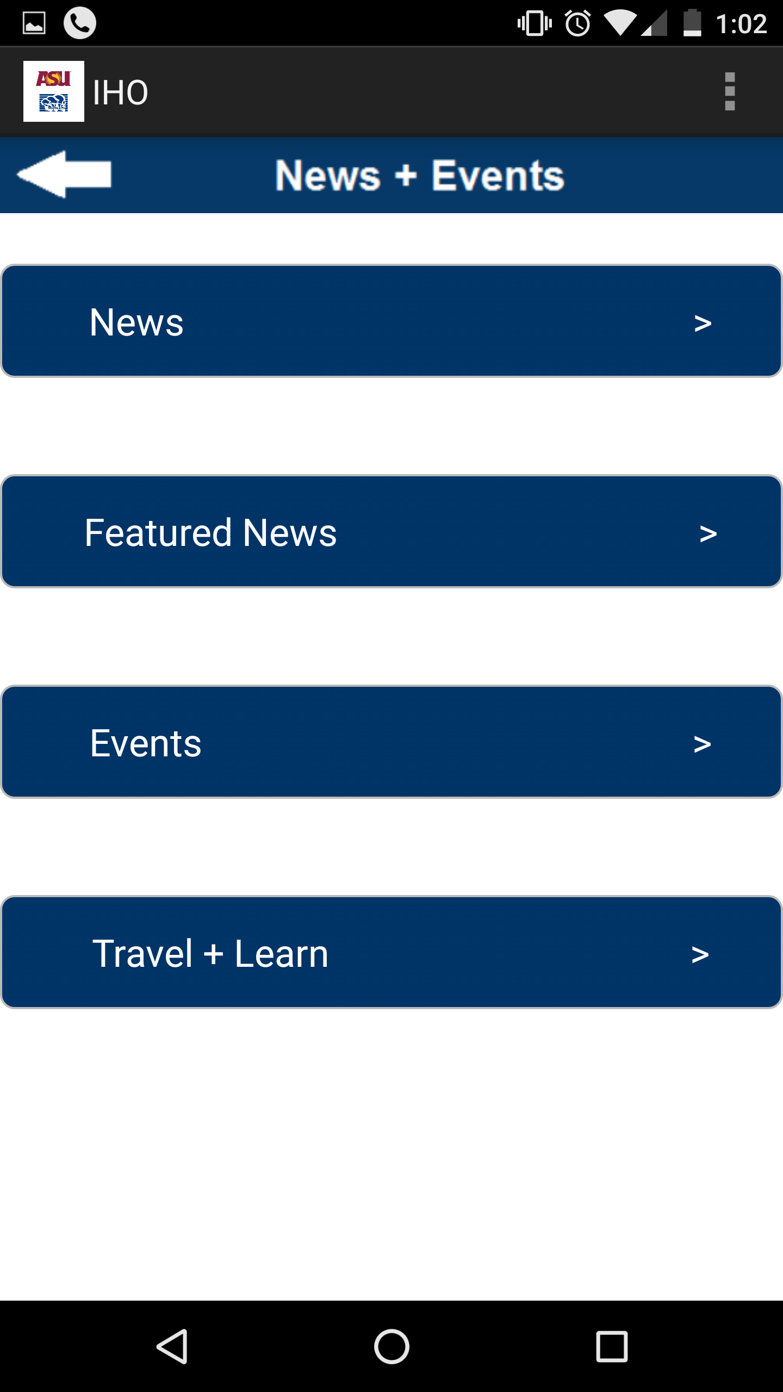

Figure 23: News + Events Application Page

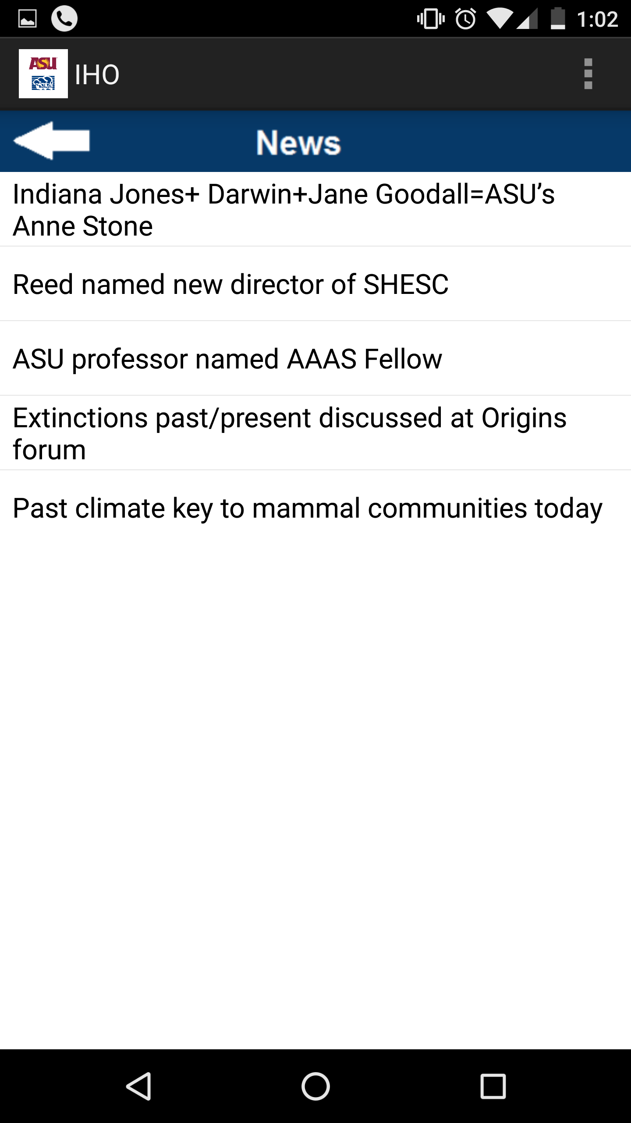

Figure 24: News List Fetched from JSON server, when clicked on News from previous screen.

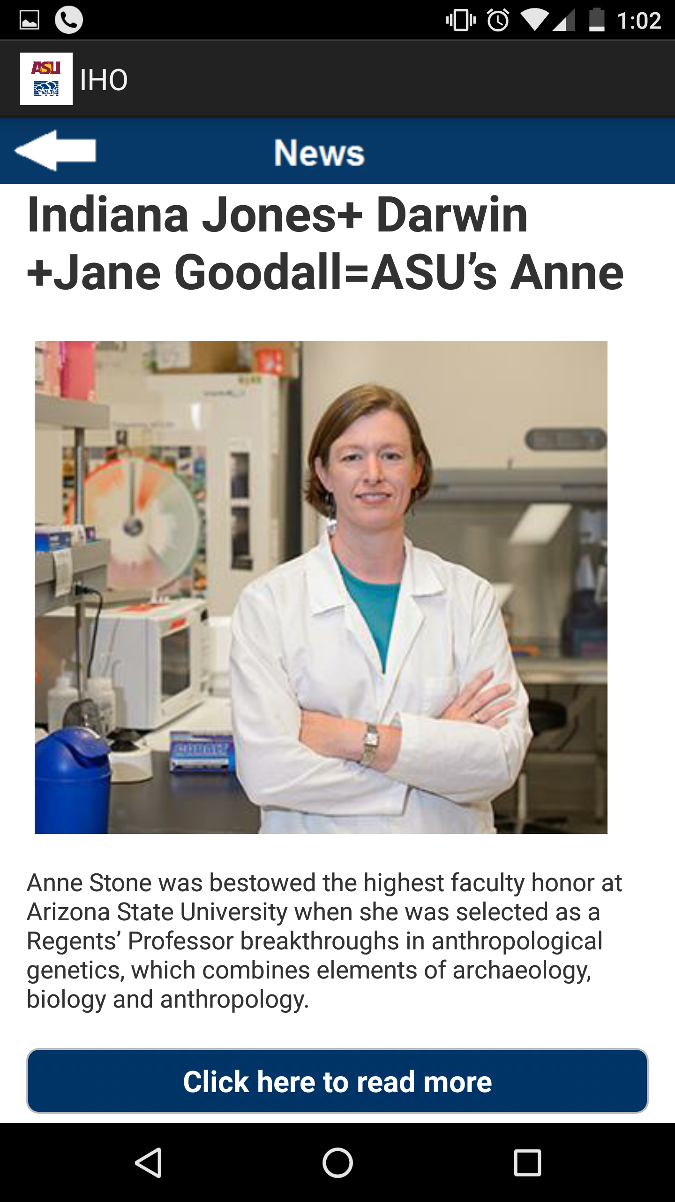

Figure 25: One of the News Items (content fetched from server)

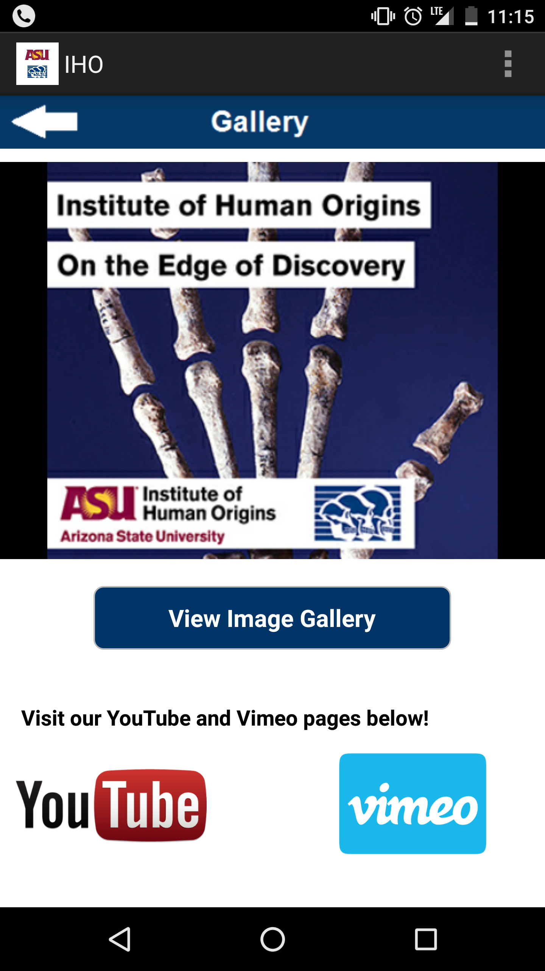

Figure 26: Gallery Home Image Screen

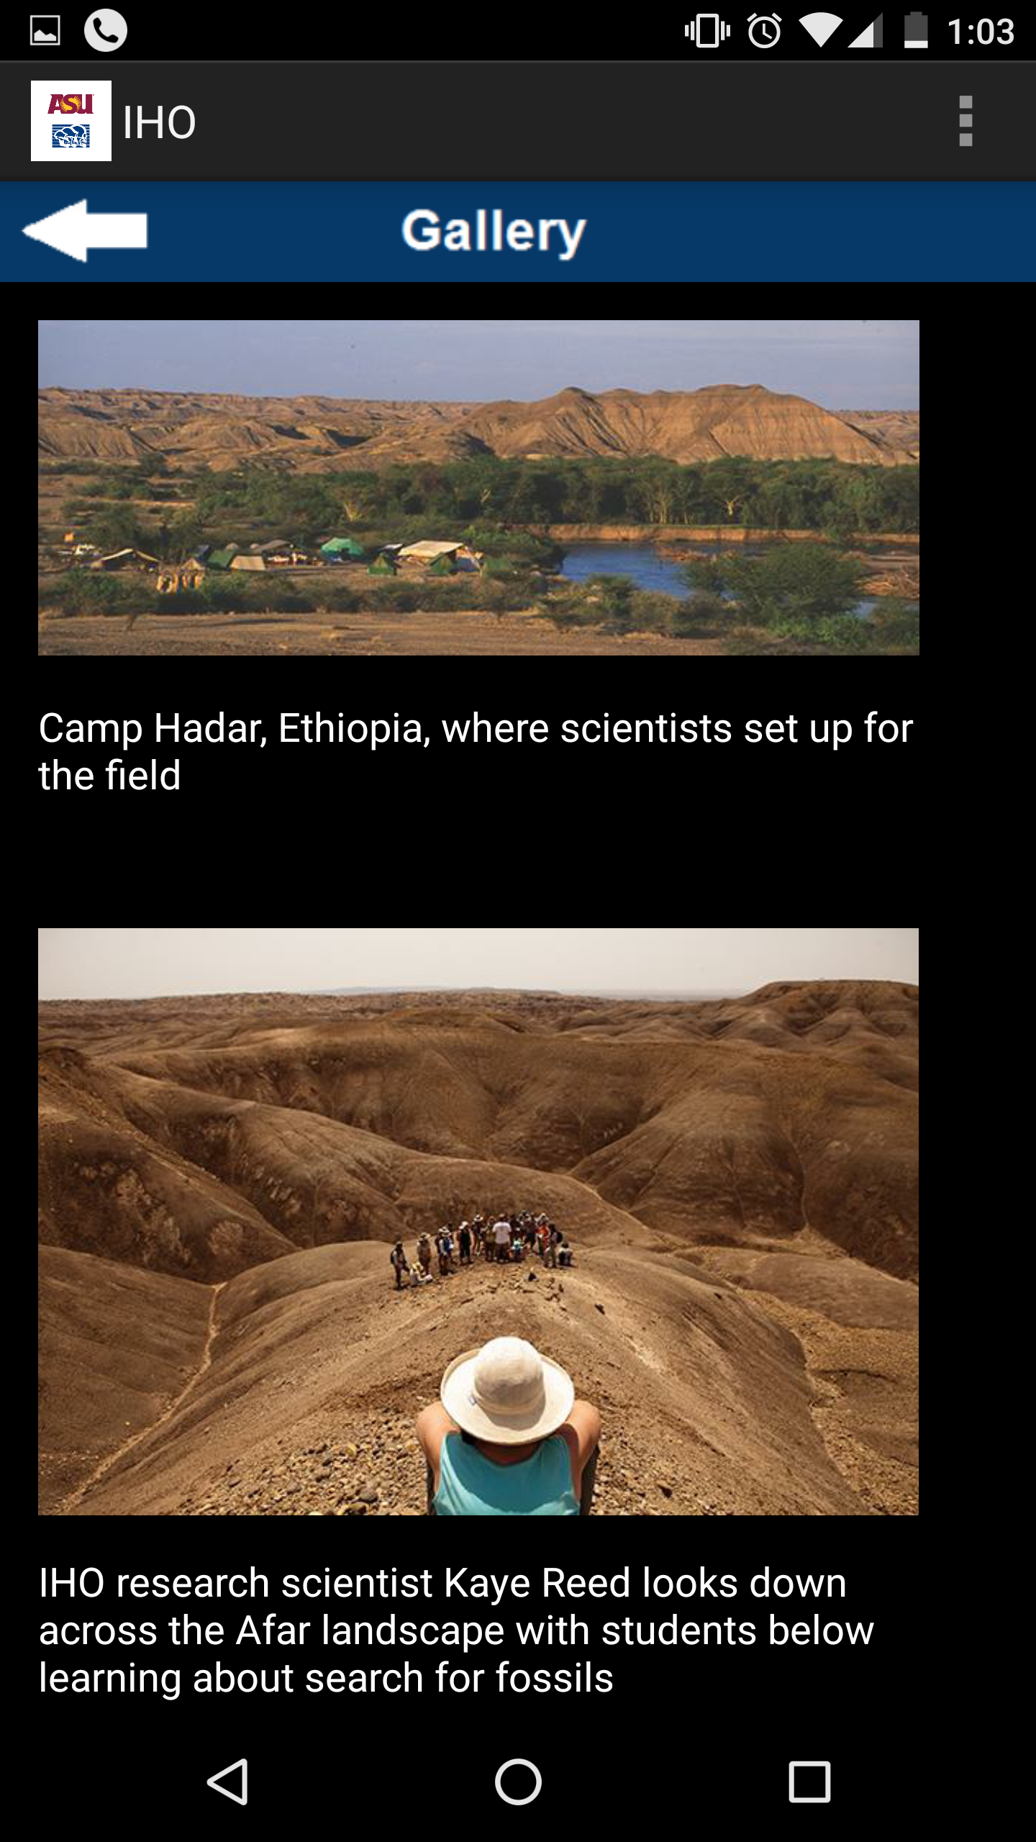

Figure 27: Gallery Image Screen (contents fetched from server and ordered as per the order given by the admin)

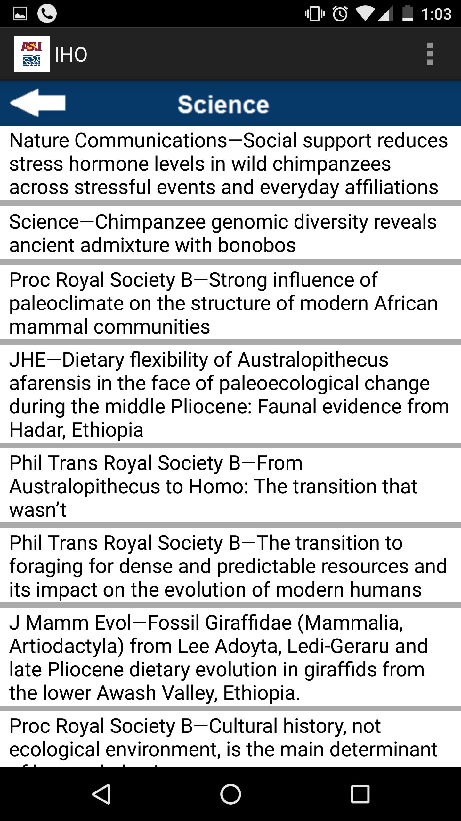

Figure 28: New Science Application Screen (content fetched from JSON server)

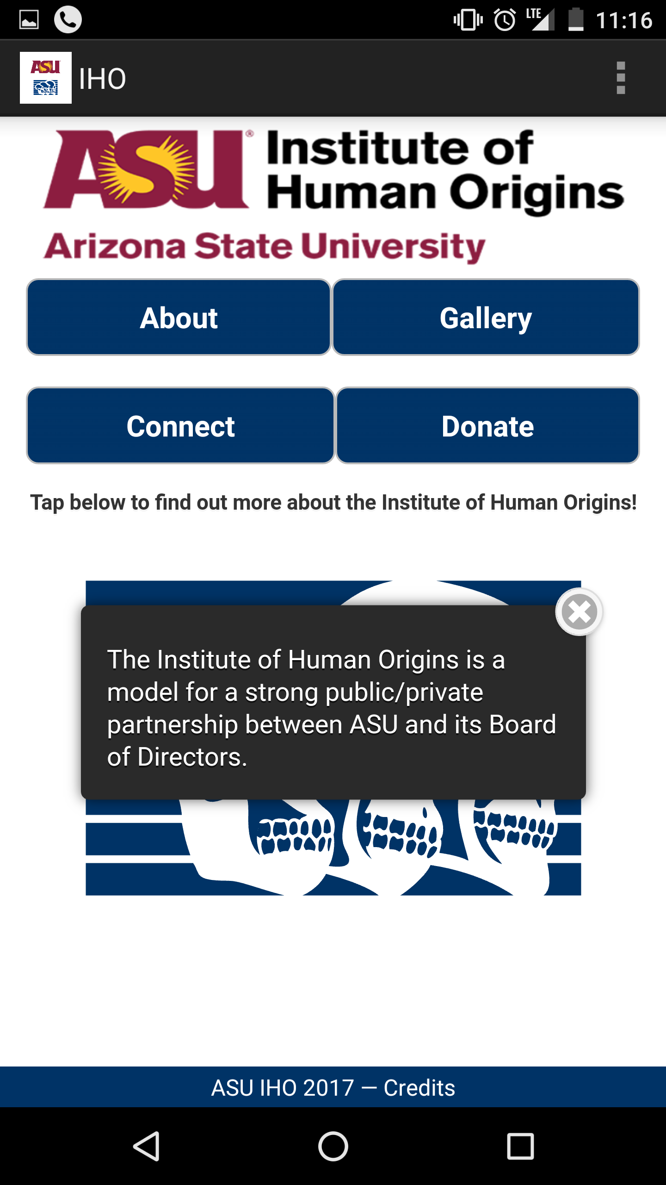

Figure 29: Interactive Skull Image showing description when touched

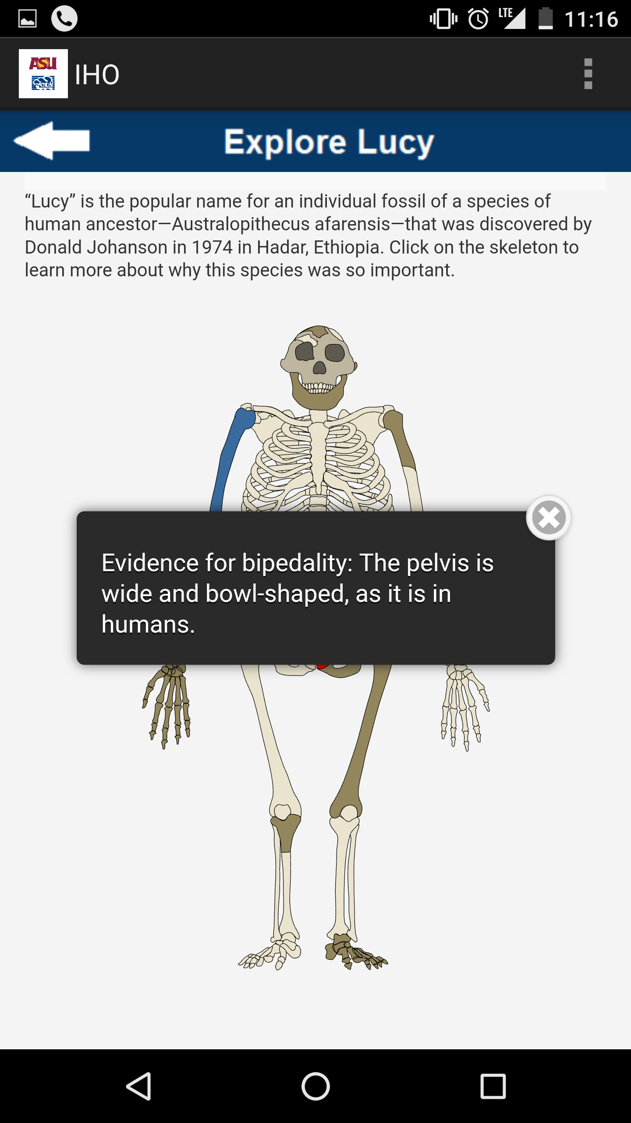

Figure 30: Interactive Lucy Image showing description when touched (changed color on touching)

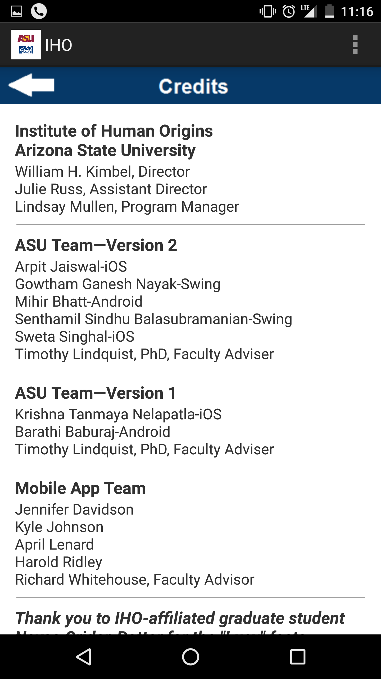

Figure 31: Updated Credit Section showing version 2 team names

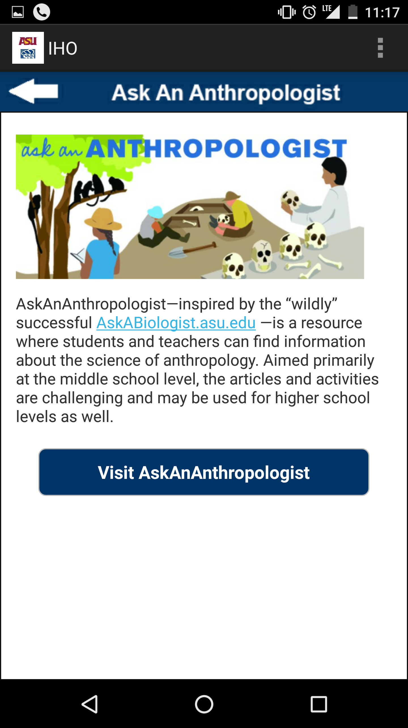

Figure 32: Ask an Anthropologist Page

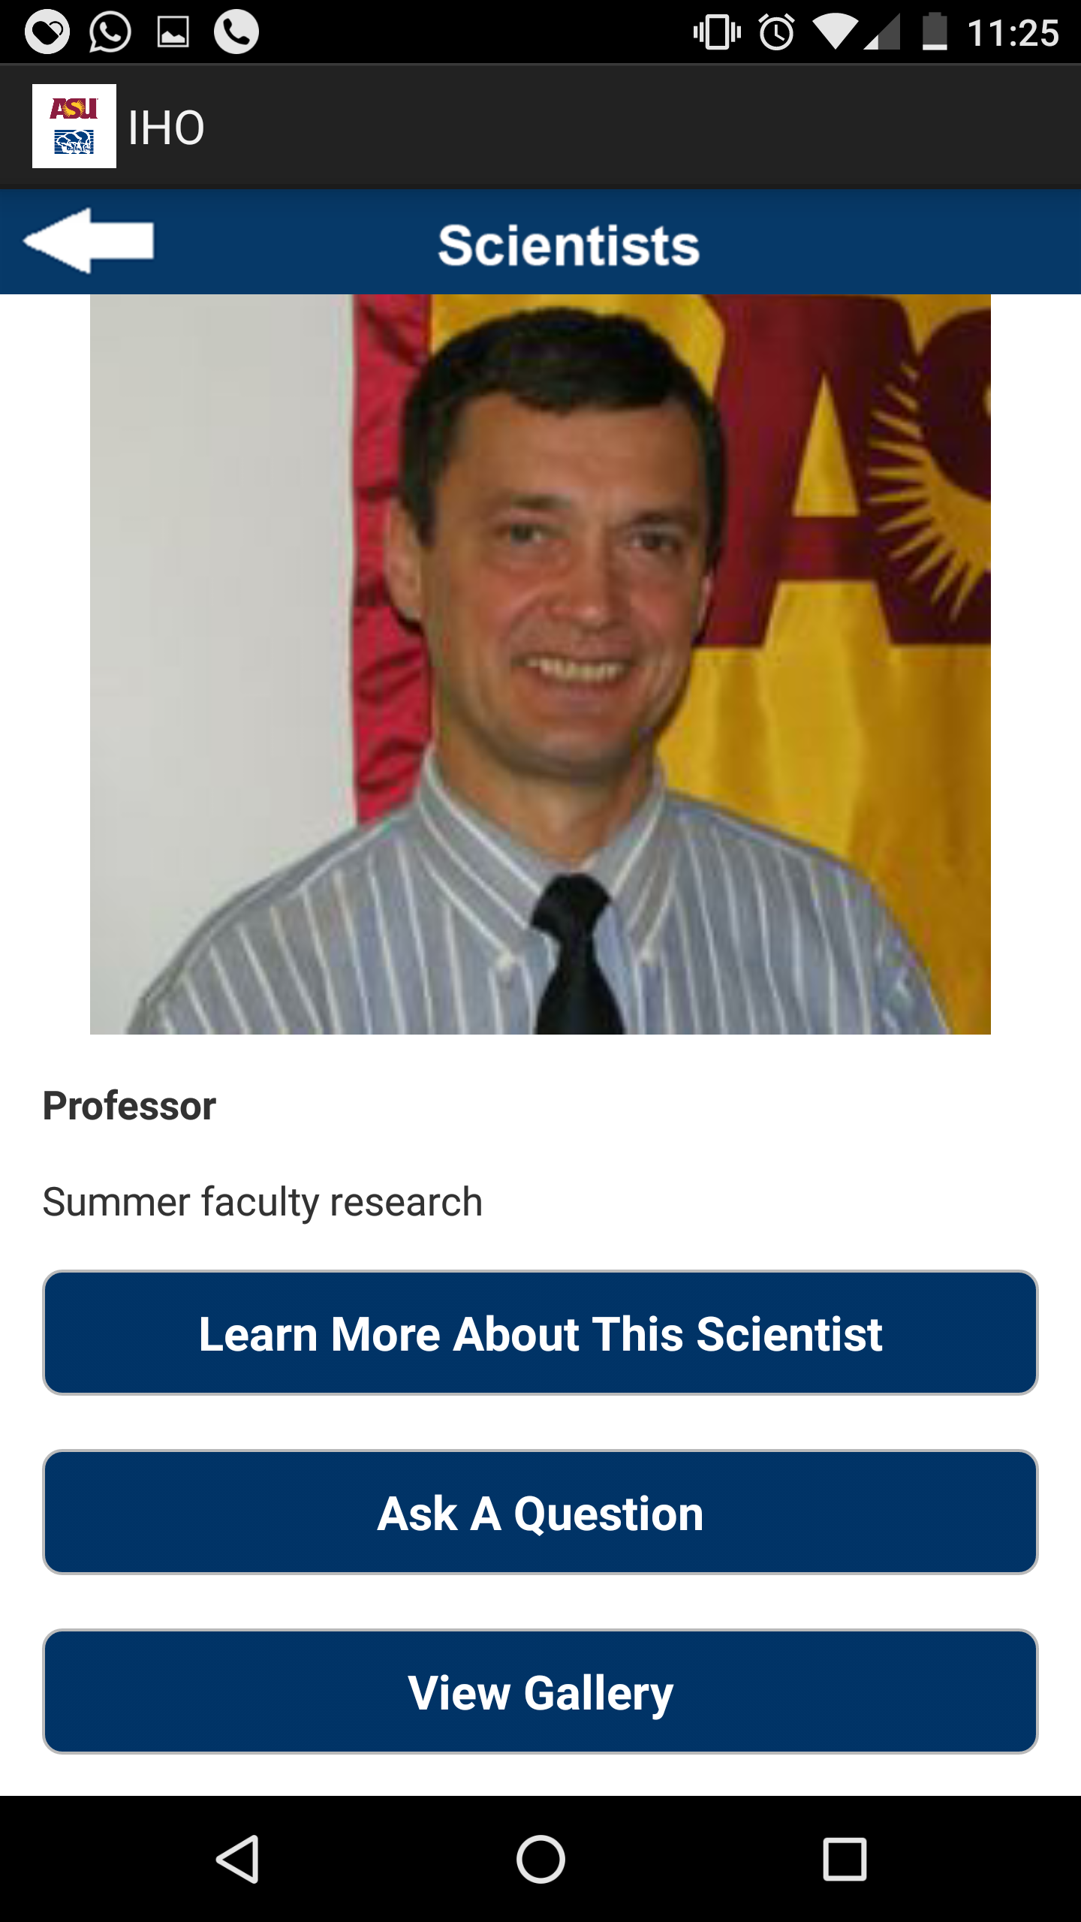

Figure 33: Scientist Page showing one of the scientists with option of Image gallery, Ask a question and page link. Ask a Question will open an email to type in the question.